Biomineralization technique in self-healing of fly-ash concrete
Authors: Font, Times New Roman;
Size, 12; Style, Plain; Location, Center
If the affiliations are different, please classify by asterisk.
Title: Font, Times New Roman;
Size, 14; Style, Bold; Location, Center
Lowercase the first letter of all title words.

Santosh Ashok Kadapure^{1*}, Girish S Kulkarni² and K.B Prakash³

¹Department of Chemical Engineering, KLE Dr MSS Shesgiri College of Engineering and Technology, Belgaum
²Department of Environmental Science & Technology, Department of Technology Shivaji University, Kolhapur
³Government Engineering College, Haveri, Karnataka
Affiliations: Font, Times New Roman; Size, 10; Location, Center
If the affiliations are different, please classify by asterisk.

Corresponding author: Font, Times New Roman; Size, 10.5; Style, Bold; location, Center. The corresponding author should be noted by an asterisk.
*Corresponding author: xxxx@xxx.xx
Email: Font, Times New Roman; Size, 10.5; location, Center.

Abstract. The main aim of running this paper is to …….
Abstract:Font, Times New Roman; Style, Bold; Size, 12
Text: Font, Times New Roman; Size, 11
Don’t put any figures and tables into abstract.

The information including title, authors, affiliations, text, keywords, and corresponding author, must put into page 1.

…. develop sustainable concrete.

Keywords: bacteria; bio-agent; sustainable fly ash concrete; self-healing; biomineralization; ….5-6 keywords
Keywords: Font, Times New Roman; Size, 11

Introduction
Introduction: Font, Times New Roman; Size, 12; Style, Bold; Location, Center
Concrete is a strong and a low cost construction material [1]. However, concrete can easily be cracked and has a limited lifespan [1]. Concrete structures are often reinforced with steel. In order for the reinforcement to take over tensile forces, concrete has to crack [2]. Existence of cracks results in increase of pore size. As a result of this, water or any other aggressive substances such as CI– and water or any other elements may enter easily into cracks [3]. If these cracks developed further, these substances may reach the reinforcement [23].
Text: Font, Times New Roman; Size, 11; 1.5 space, Indentation, First line 0.35cm
……………………………………………………………………………………………………………………………………………………………………………….
From page 2, please start Introduction.
When you insert figures and tables, please make them clear in color or black-white printing.

Subtitle: Font, Times New Roman; Size, 11; Style, Bold; Location, Left.
Material and Methodology: Font, Times New Roman; Size, 12; Style, Bold; Location, Center

Material and Methodology
Cement and sand
An ordinary Portland cement (Table 1) having fineness of 248 m2/kg and specific gravity of 3.15 was used throughout the experiment.
Result and Discussions: Font, Times New Roman; Size, 12; Style, Bold; Location, Center

Result and Discussions
…………………………………………………………………………………………………………
Conclusions: Font, Times New Roman; Size, 12; Style, Bold; Location, Center

Conclusions
…………………………………………………………………………………………………………
Acknowledgements: Font, Times New Roman; Size, 12; Style, Bold; Location, Center

Acknowledgements
The authors would like to thank the management authorities of KLE DR .M.S.Sheshgiri College of Engineering and Technology, Belgaum for their kind support. The authors are grateful to Dr. Basavaraj G. Katageri for giving all the encouragement needed which kept the enthusiasm alive.
References: Font, Times New Roman; Size, 12; Style, Bold; Location, Center

References
[1] S.A. Barbhuiya, J.K. Gbagbo, M.I. Russell, and P.A.M. Basheer, Properties of fly ash concrete modified with hydrated lime and silica fume, Construction and Building Materials. 23(10) (2009), pp. 3233-3239.
[2] S.A.L. de Koster, R.M. Mors, H.W. Nugteren, H.M. Jonkers, G.M.H. Meesters, J.R. van Ommen, Geopolymer Coating of Bacteria-containing Granules for Use in Self-healing Concrete, Procedia Engineering. 102 (2015), pp. 475-484.
[3] N.K. Chahal, Rafat Siddique, and Navneet Kaur, Effect of ureolytic bacteria on concrete properties, Construction and Building Materials. 25(10) (2011), pp. 3791-3801.
[4] Henk M. Jonkers and Erik Schlangen, A two component bacteria-based self-healing concrete, Concrete Repair, Rehabilitation and Retrofitting II-Alexander et al (eds)© 2009 Taylor & Francis Group, London, ISBN 978-0- 415-46850-3.
[5] WoutKnoben, Bacteria care for concrete, Materials today Volume 14, Issue 9, September. (2011), pp. 444.
[6] Bang Sookie, Ramachandran Santhosh,Ramakrishnan V, and Sookie S, Remediation of concrete using Micro- organism, ACI Materials Journal. (2001). DOI: 10.14359/10154.
[7] Semsi yazici, and Hasan Sahan, Effects of fly ash fineness on the mechanical properties of concrete, Sadhana 37(3) (2012), pp. 389-403, Indian Academy of Sciences.
[8] Varenyam Achal, Abhijit Mukherjee, Deepika Kumari, and Qiuzhuo Zhang, Biomineralization for Sustainable Construction-A Review of Processes and applications, Earth Science Reviews S0012-8252(15)00091-4 .
[9] Luo Mian Qian Chunxiang, LI Ruiyang, and Rong Hui, Efficiency of Concrete Crack-healing based on Biological Carbonate Precipitation,. Journal of Wuhan University of Technology-Mater. Sci. Ed. www.jwutms.net Dec.2015.
How to organize the reference list.
References are given in the text by bracketed numbers [1], with a list of references at the end of the article in numerical order. Most books and articles are classified by subfield and uniquely identified in the Mathematical Reviews (MR) Database. This MR number can be included as the last item in each reference. The MR Database is searchable at http://www.ams.org/mrdatabase.

Text: Font, Times New Roman; Size, 12
Table 1: Font, Times New Roman; Size, 12; Style, Bold
Table
Table 1. Properties of cement and fly ash used.
Chemical compound | Fly ash | Cement
Al₂O₃ | 26.7 | 3.8
Fe₂O₃ | 6.1 | 3.36
CaO | 0.70 | 66
MgO | 0.60 | 2.8
LOI | 1.80 | <2
K₂O | 1.2 | 0.6
Total Alkalis as Na₂O | 0.93 | 0.28
Chloride | 0.06 | .011

When you insert figures and tables, please make them clear in color or black-white printing.
Figure
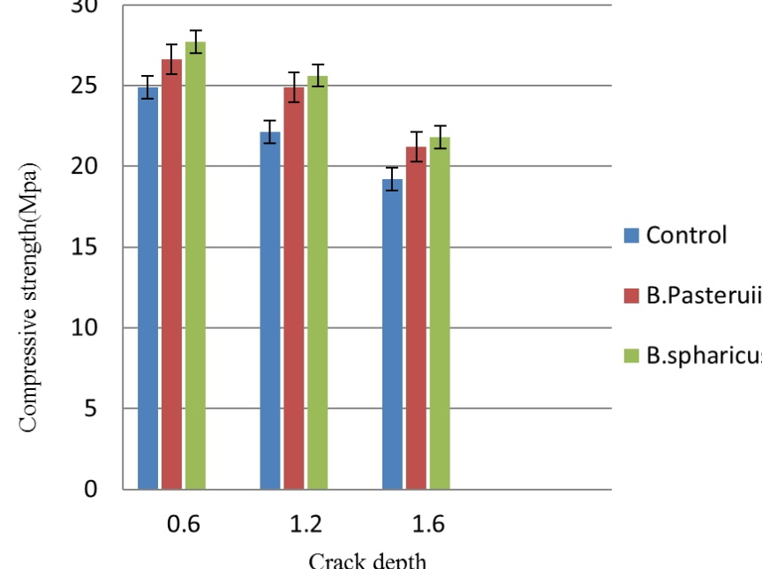
Figure 1: Font, Times New Roman; Size, 12; Style, Bold

Figure 1. Compressive strength of bioremediated fly ash specimens (days of curing). Error bar shows standard deviation.
Text: Font, Times New Roman; Size, 12

